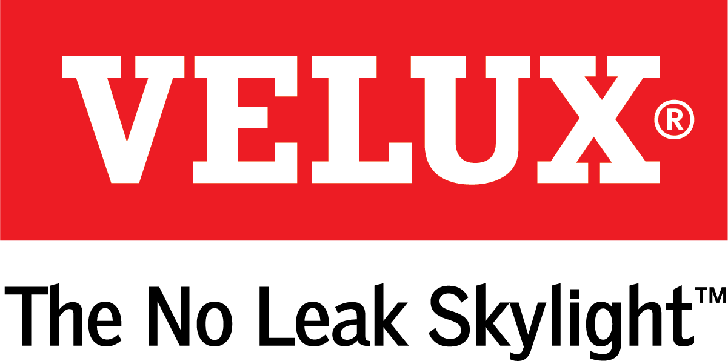
Media Contacts:
Kelsey Webb
704-790-1560
kwebb@wrayward.com

Dana Haydock
704-926-1301
dhaydock@wrayward.com

SUN TUNNEL SKYLIGHTS ARE COST EFFECTIVE OPTION

TO TRANSFORM ROOMS WITH NATURAL LIGHT
With Solar Night Light Kit Installed, They Qualify for a 26% Federal Tax Credit

LAS VEGAS, Jan. 21-23, 2020 – VELUX Sun Tunnel Skylights are a quick, inexpensive option to transform a space with natural light. The product, which can be installed in as little as 90 minutes, fits in a ceiling like recessed lighting but actually funnels natural light through a prefabricated reflective aluminum tunnel from the roof through the attic to the room below.
“Sun Tunnels are a great way to add space-changing natural light to a room,” said Ross Vandermark, national product manager for VELUX America. “Plus, VELUX offers a variety of accessories so homeowners can control the exact amount of light they want entering their rooms at any given time.”
An optional daylight controller allows homeowners to control the amount of daylight that enters the room, making it a practical option for rooms, like bedrooms, that may need to be darkened. And at night, a solar night light installed inside the reflective tunnel provides guiding light and enables the product to qualify for the 26% federal tax credit on solar property.
Sun Tunnels can be customized with decorative diffuser films, available in six styles that complement many interior designs:
- Micro Fresnel is a simple, yet effective design that provides unprecedented optical quality and focused light.
- Triple Wave consists of soft curves etched into the diffuser film that naturally diffuse the light while adding a unique design element to the Sun Tunnel Skylight.
- Much like the hardware in a home, Brushed Metal is a subtle yet effective option for enhancing the style of a room.
- The Prismatic design ensures that natural light is spread evenly throughout the room.
- The Bubbles design is perfect for homeowners who are looking to add an extra element of design to their fifth wall.
- Neutral Light converts daylight to appear more like a traditional household light bulb with a warm yellow bias.
For more information on purchasing and installing VELUX Sun Tunnels, visit veluxusa.com/products/sun-tunnels.

# # #

VELUX is the world leader in skylights and roof windows and is one of the strongest brands in the global building materials sector. VELUX products are available nationwide through home centers, building material suppliers, lumberyards and independent door, window or roofing retailers. Consumers can locate local suppliers and installers and access information on skylight selection and the benefits of bringing more natural light and fresh air into the home by visiting www.veluxusa.com or www.whyskylights.com. VELUX skylights are made in America in Greenwood, South Carolina.

